STUDENT PORTAL
BY
OKIE DOKIE
-
HOW TO PAY FEE THROUGH STUDENT APP

Step-1: Scan the QR code and Download the Student App by Okie Dokie.

Step-2: Enter your Registered Mobile No. and Click on Request OTP.
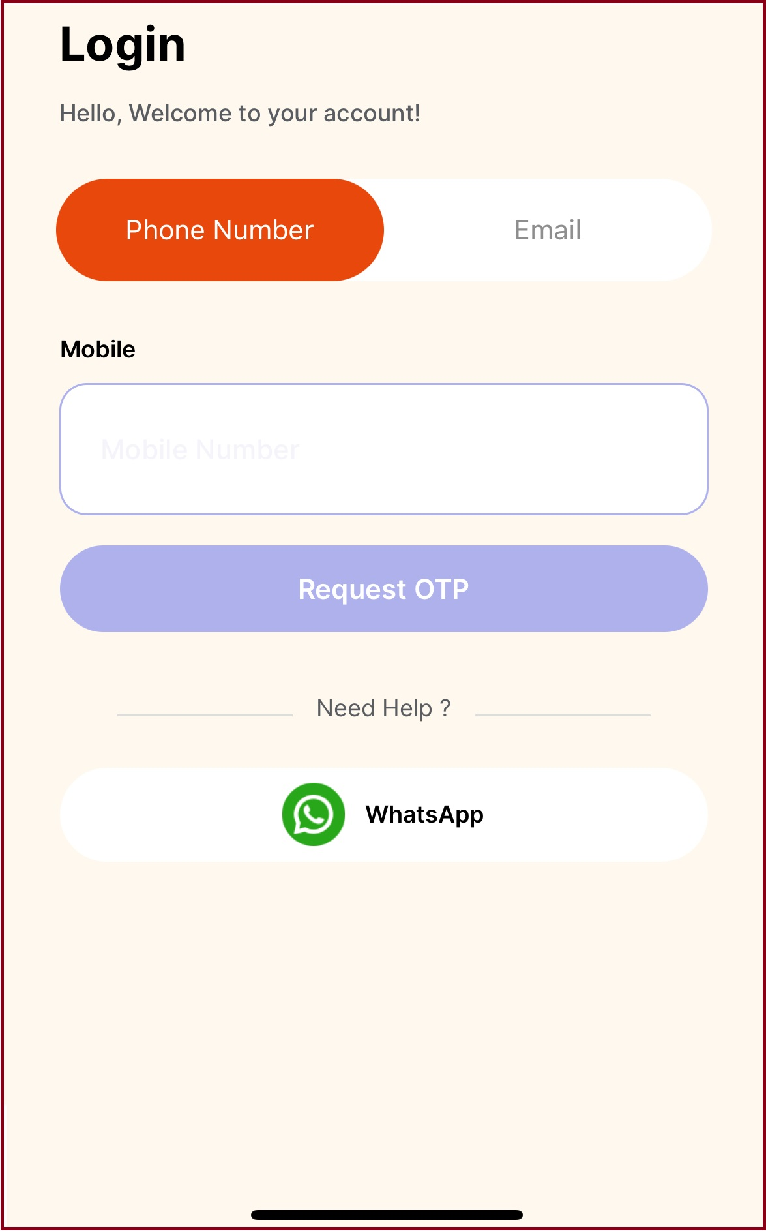

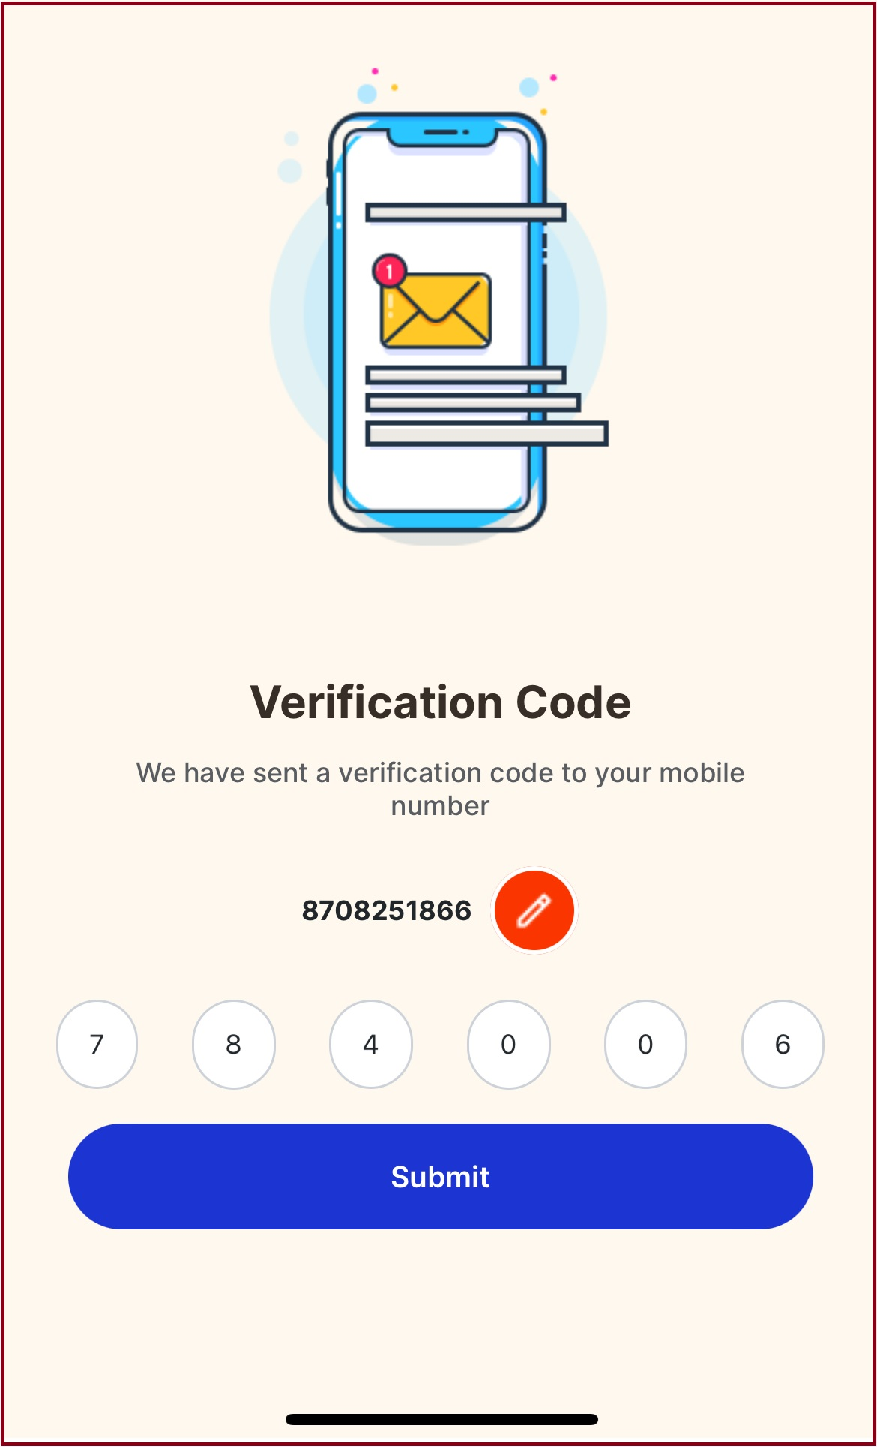
Step-3: Enter OTP received on Registered Mobile No. and Click on Submit Button.

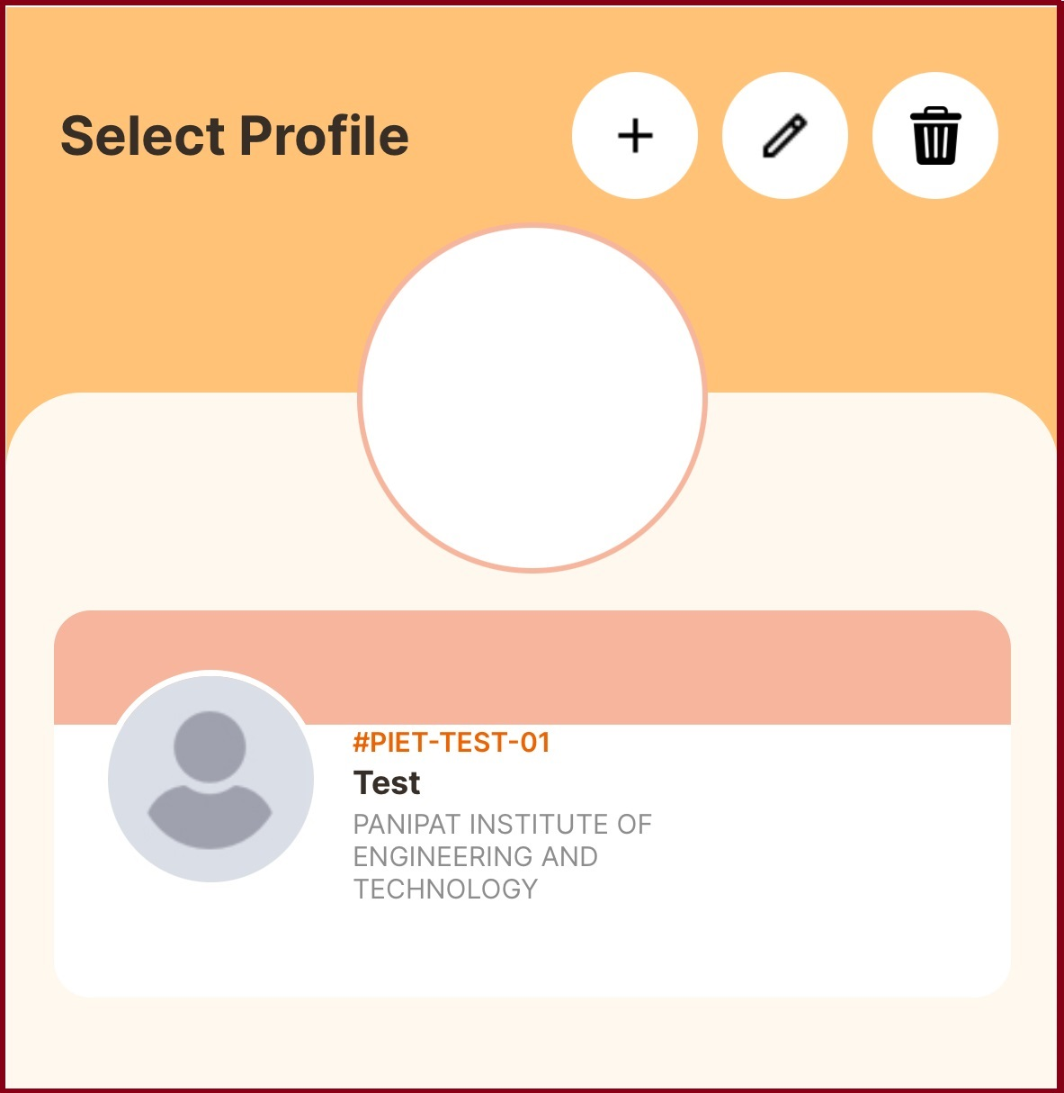
Step-4: Click on your Profile Tab as shown Below: Test.
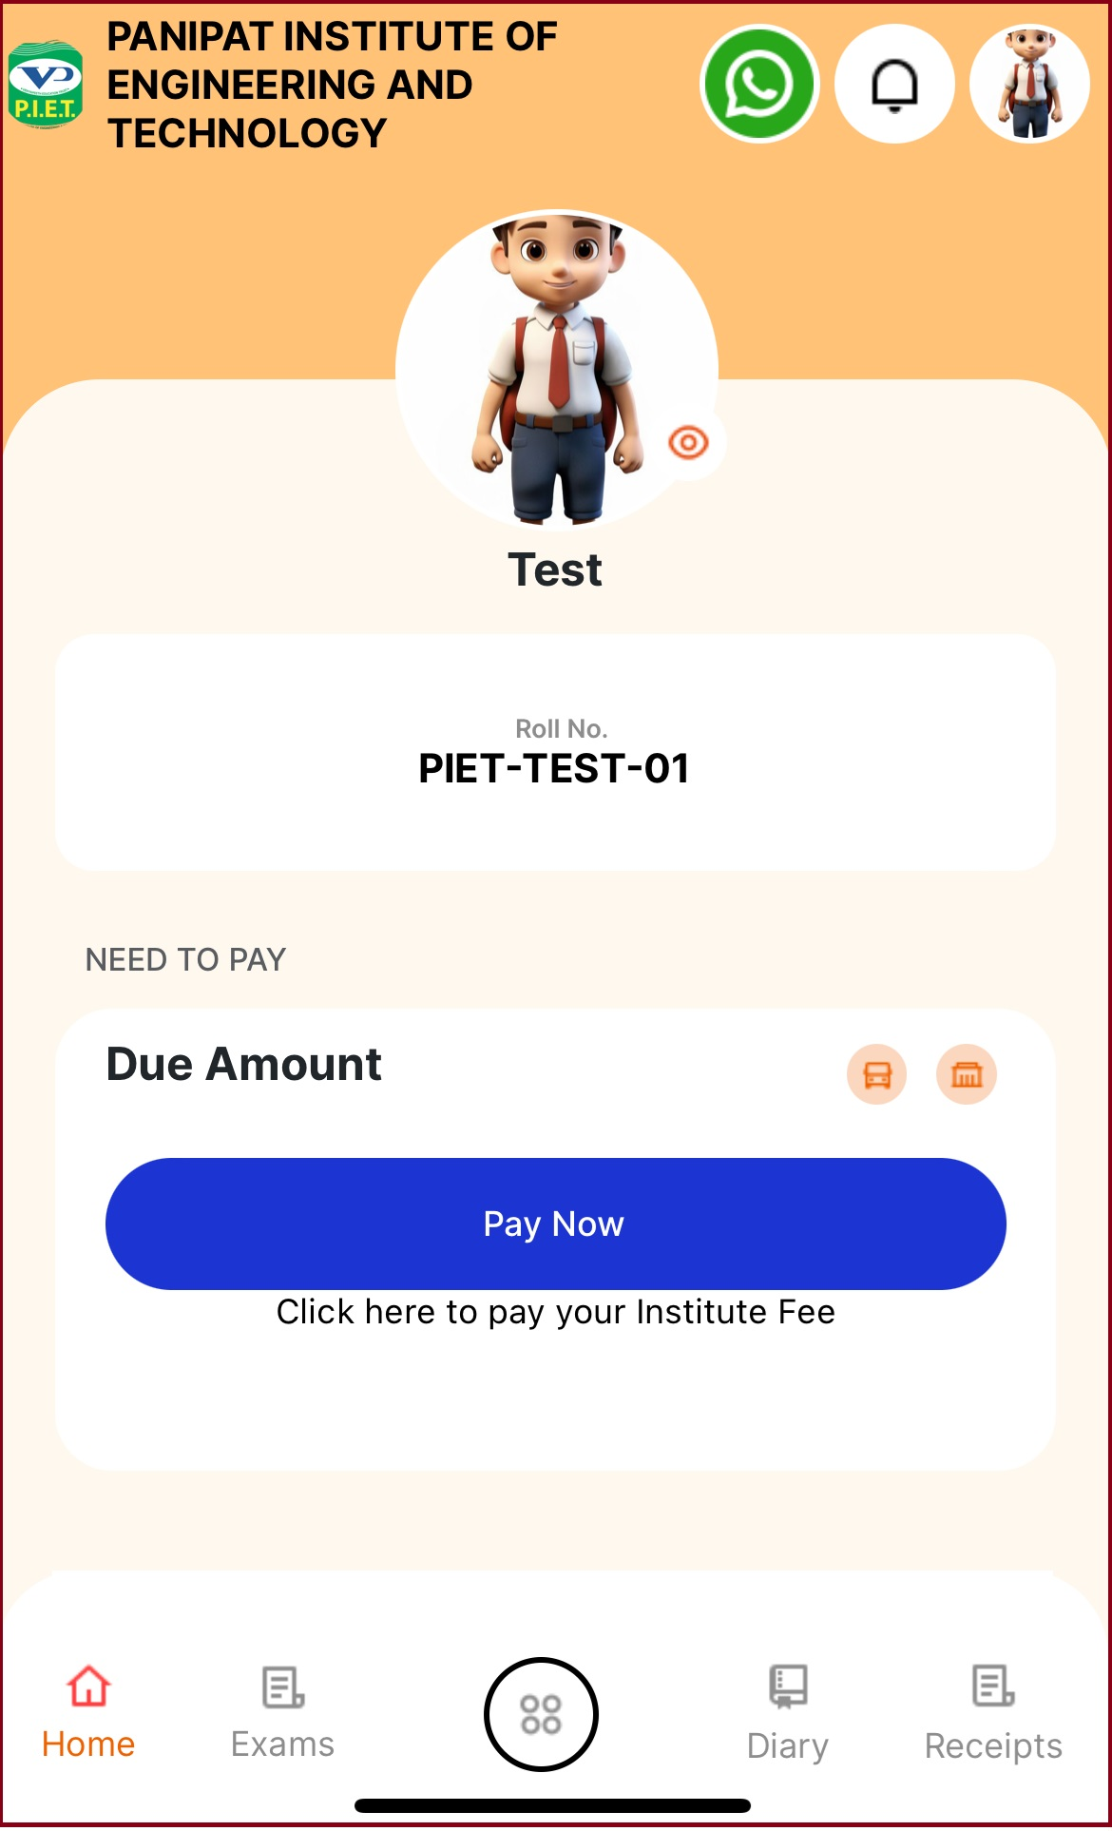
Step-5: Click on Pay Now Button for Fee Payment.

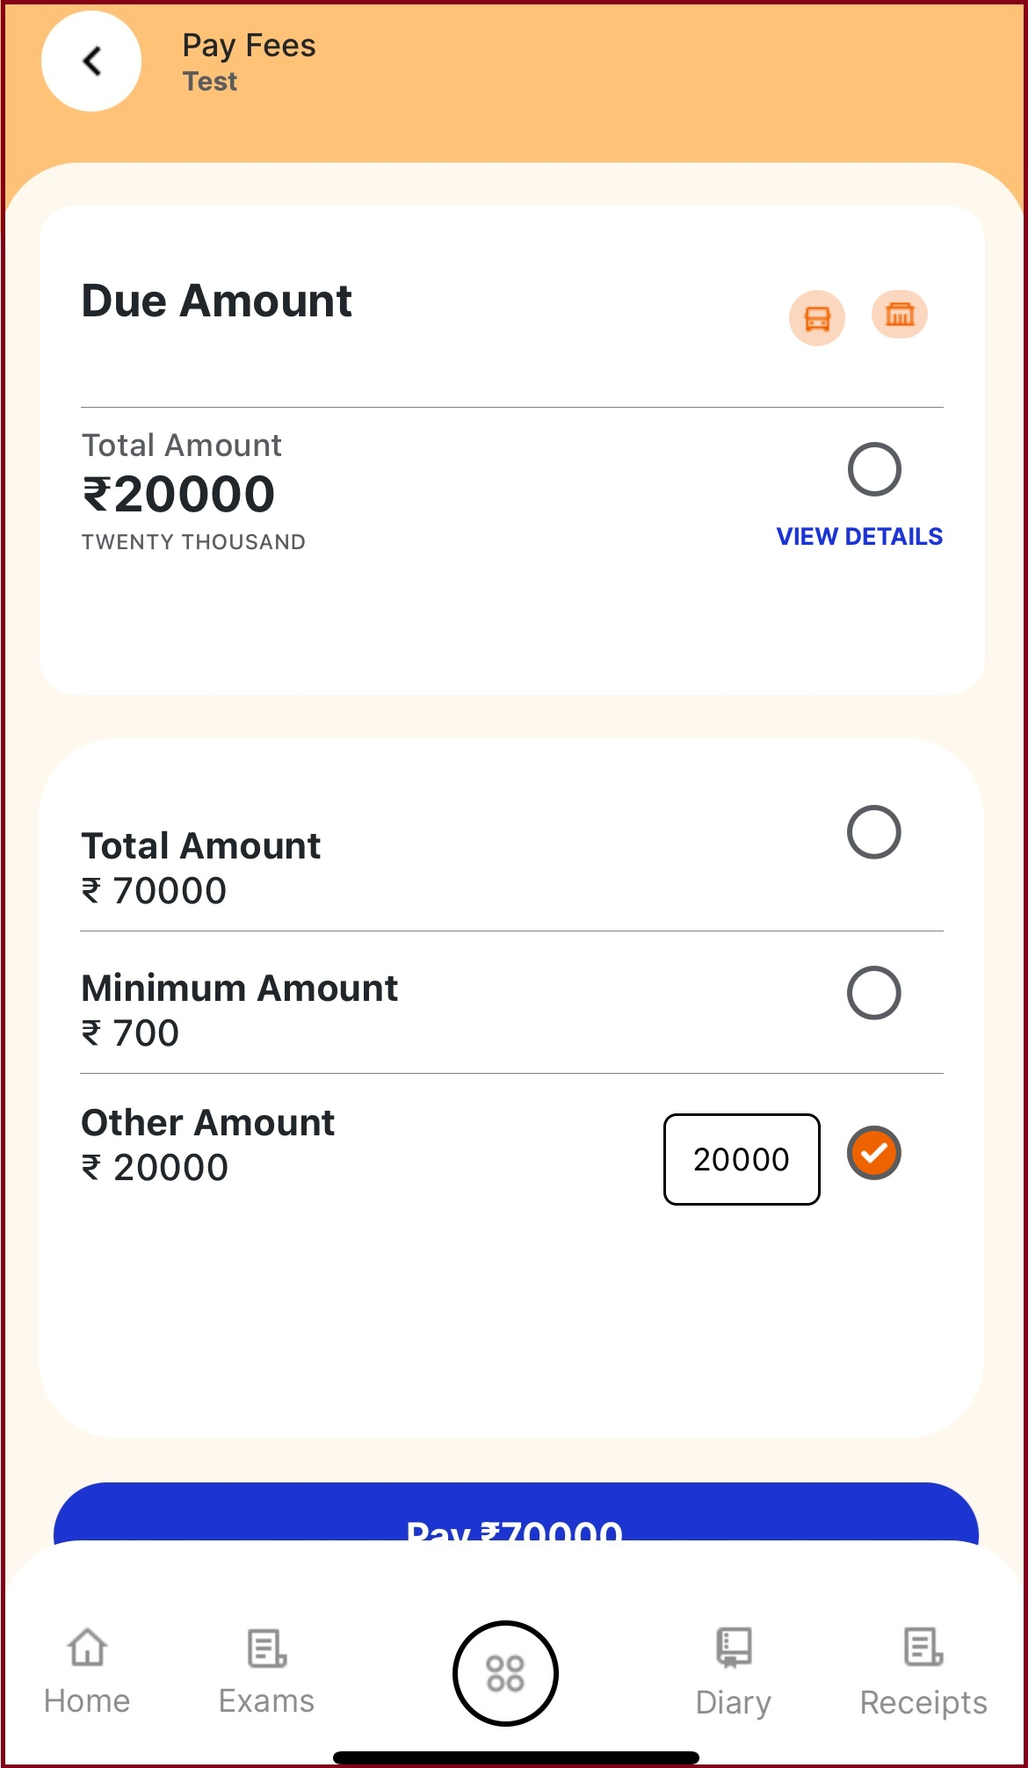
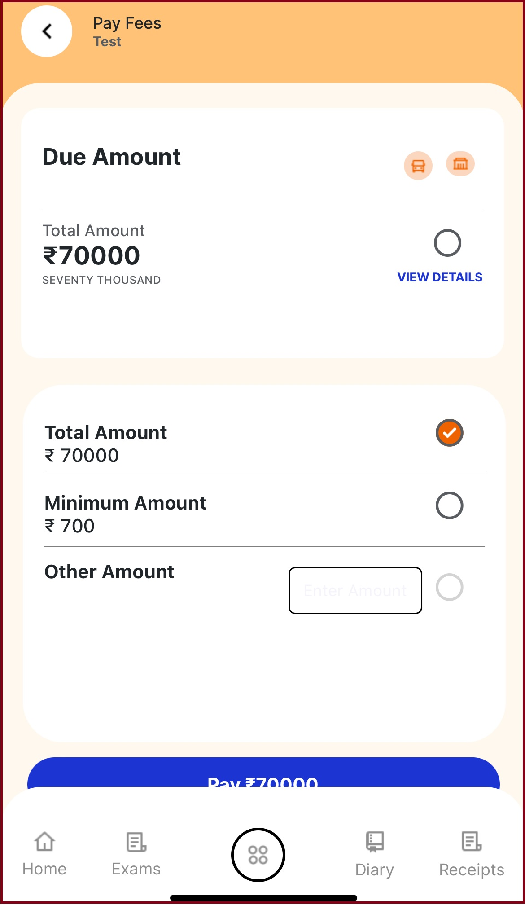
Step-6: Select Total Amount / Other amount option for Partial Payment.

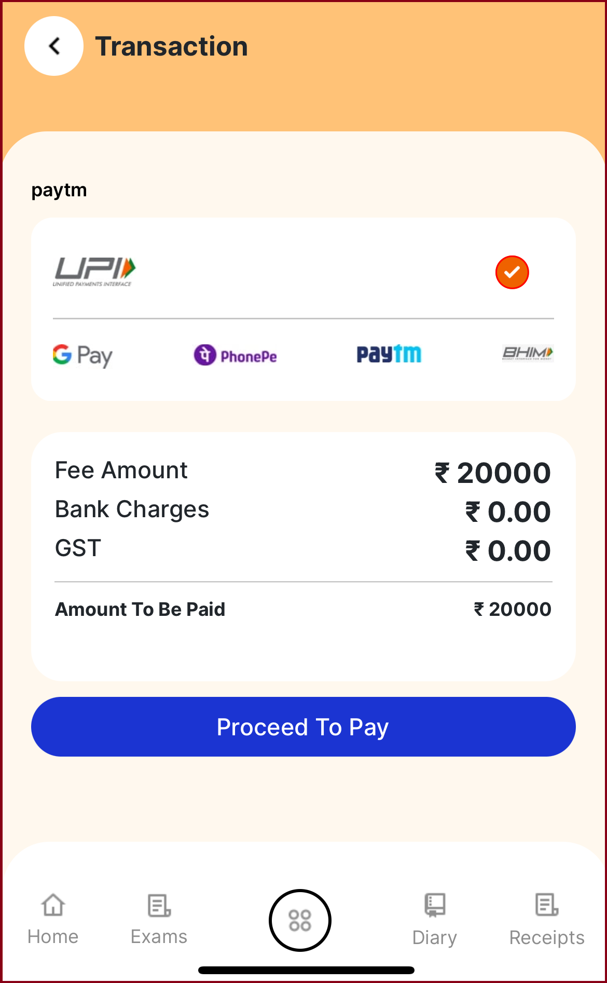
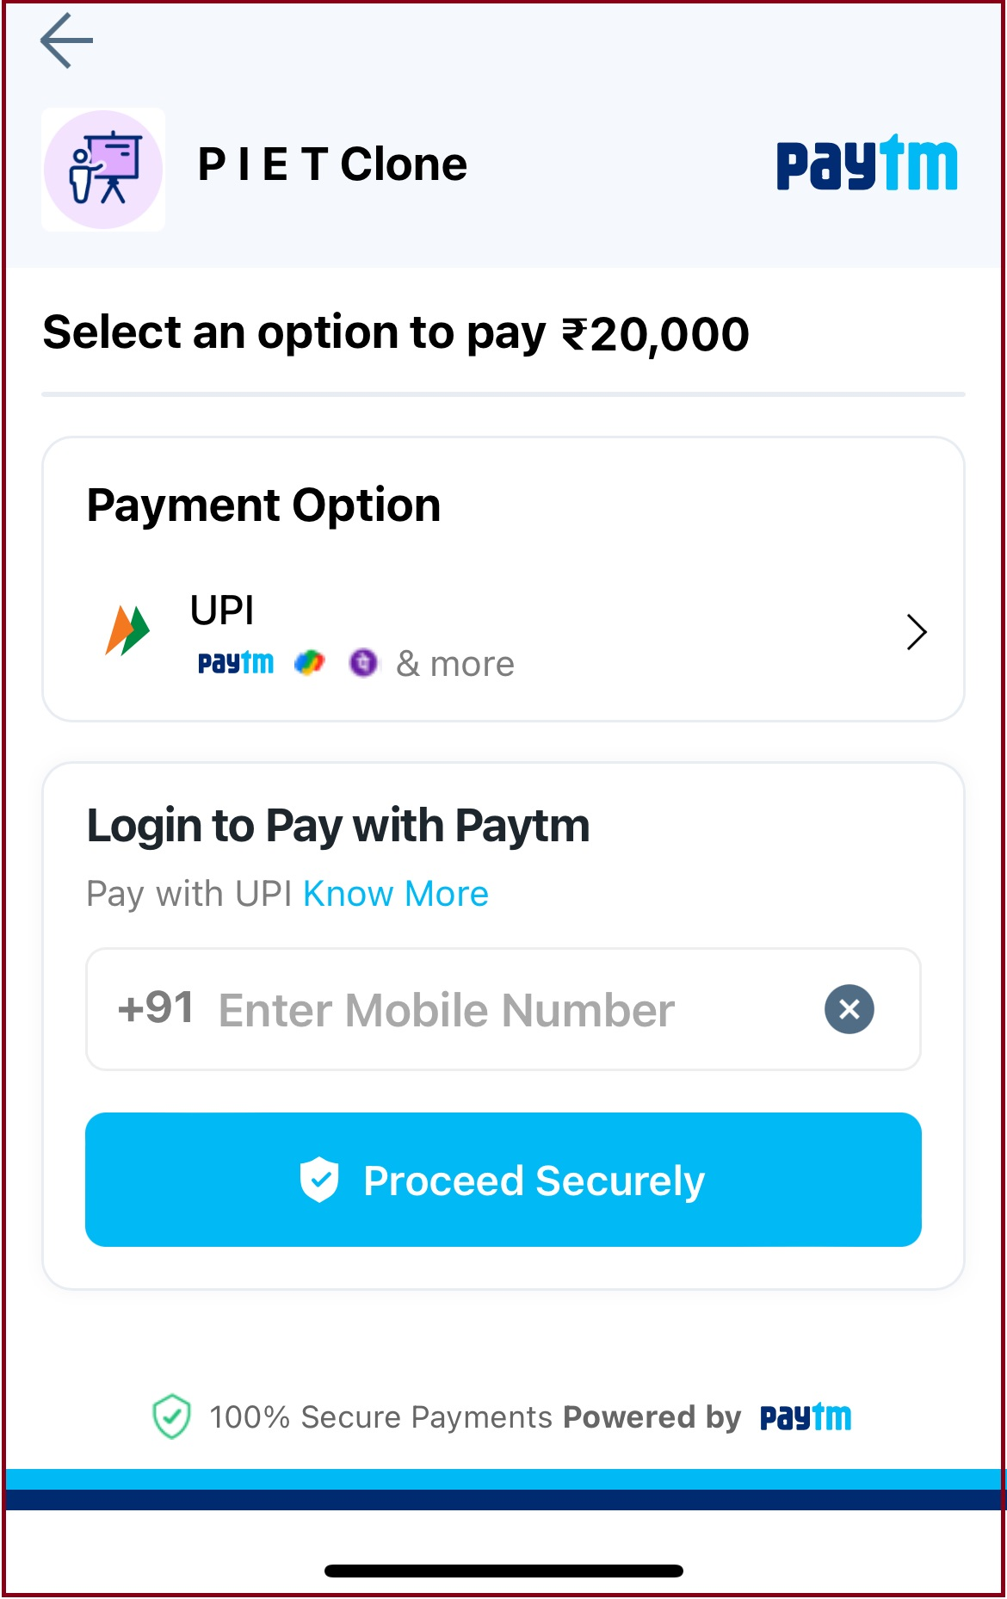
Step-7: Select UPI and Click on Proceed to Pay Button for making payment.


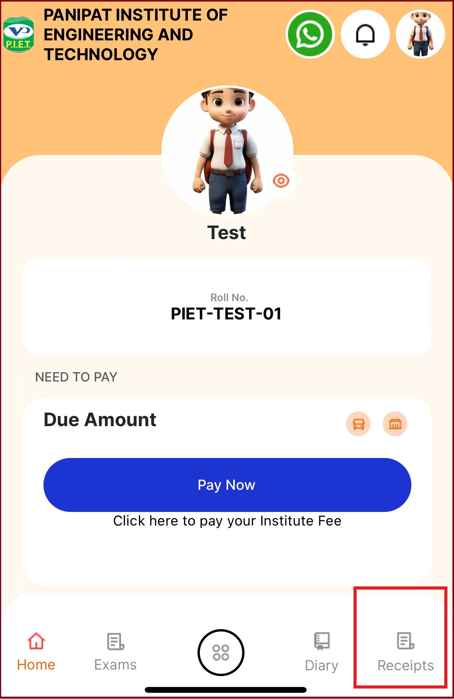
Step-8: After Successful Payment you can View /Download Fee Receipt.

